**Q1. [50] Decision Tree**

Suppose we have a system that observes a person’s TV watching habits in order to recommend other TV shows the person may like. Suppose that we have characterized each show by whether it is a comedy, whether it features doctors, whether it features lawyers, and whether it has guns. The examples about whether the person likes various TV shows are given in the table.

|  |  |  |  |  |  |
| --- | --- | --- | --- | --- | --- |
| Example # | Comedy | Doctors | Lawyers | Guns | *Likes* |
| e1 | false | true | false | false | *false* |
| e2 | true | false | true | false | *true* |
| e3 | false | false | true | true | *true* |
| e4  e5  e6  e7  e8  e9  e10  e11  e12 | false  false  true  true  false  false  true  true  false | false  false  false  false  true  true  true  true  false | true  false  false  false  true  true  true  false  false | false  true  true  false  true  false  false  true  false | *false*  *false*  *false*  *true*  *true*  *false*  *true*  *false*  *false* |

This data is used to learn the value of *Likes* (i.e. to predict which TV shows the person would like based on the attributes of the TV show). Suppose we measure the error of a decision tree as the number of misclassified examples. The optimal decision tree from a class of decision trees is an element of the class with minimal error.

**Answer**

1. **[10] (A) Give the optimal decision tree of depth 1, with only one node. Note that a depth of root is 0.**

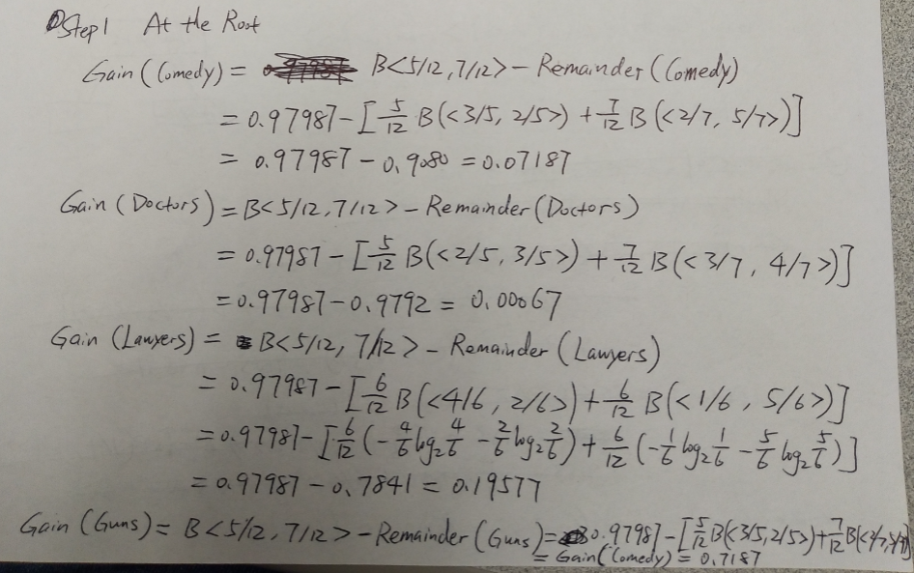



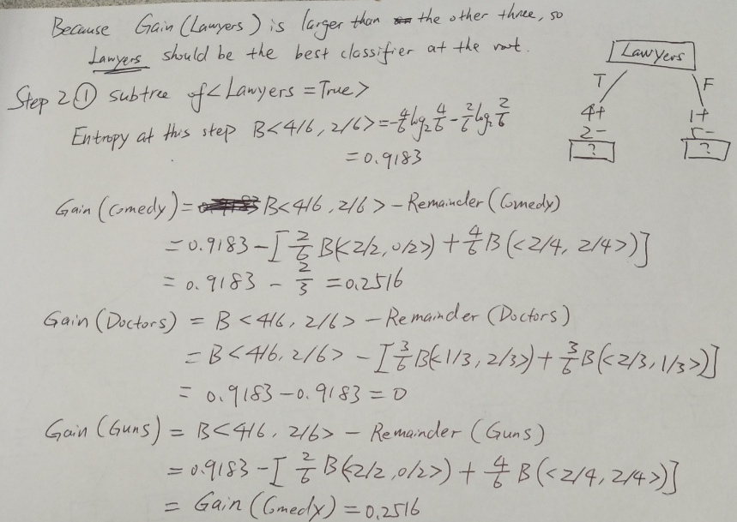

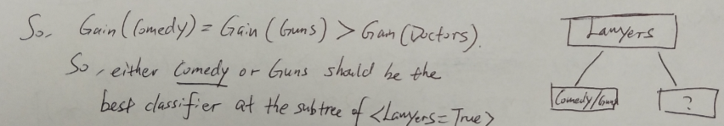

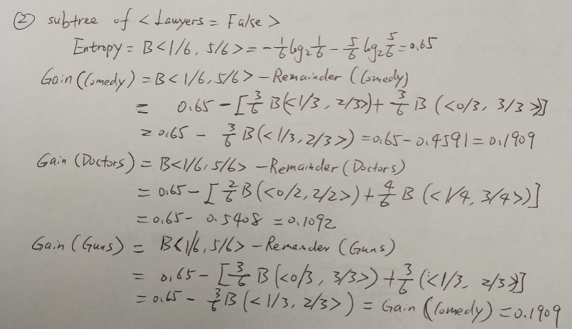

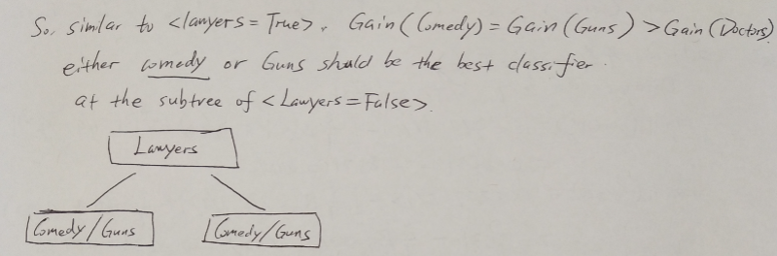

So, this is the optimized decision tree with depth 1

**(B) Suppose that the error is the 0/1 loss. What is the error of this tree? .**

0/1 loss:

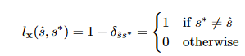

Where δ is the Kronecker Delta function. This loss function is an appropriate choice when the same penalty is incurred whenever the estimate does not exactly correspond to the true underlying variable (and none otherwise), regardless of how far from the truth the estimate actually is. It makes most sense when the hypothesis space (the space of values s can take on) is discrete.

1. **[5] Compute the initial entropy of *Likes*.**



1. **[15] Draw the full decision tree that is learned from the above data by optimizing the information gain at each step. Show the computation of information gain to choose a root of each subtree.**

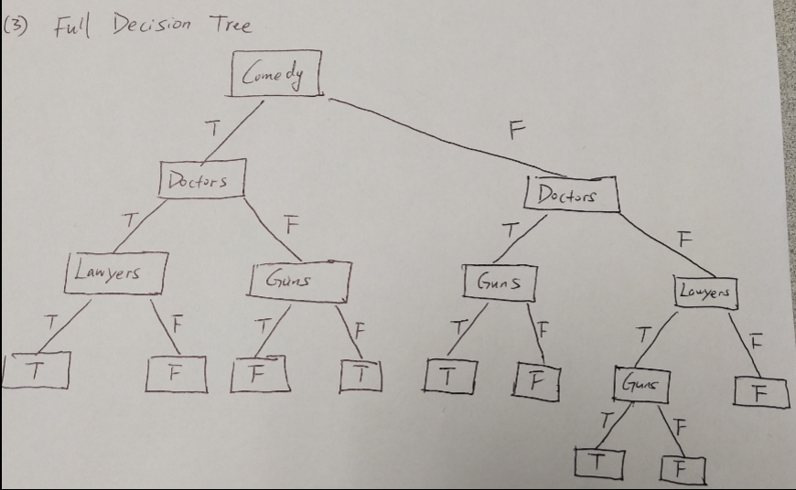

Then calculate Information gain at each step to optimize the tree













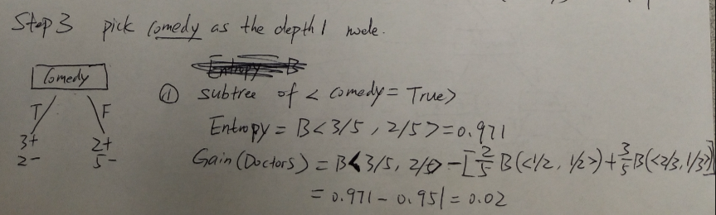

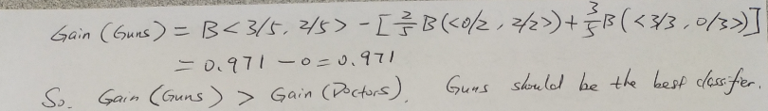

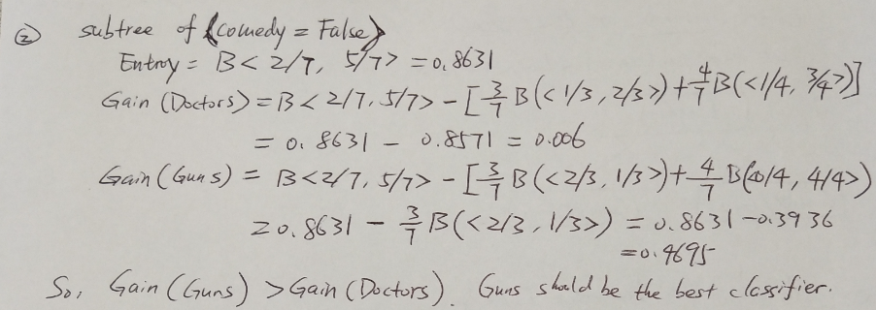

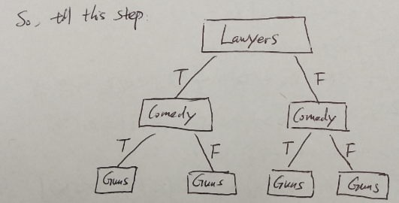

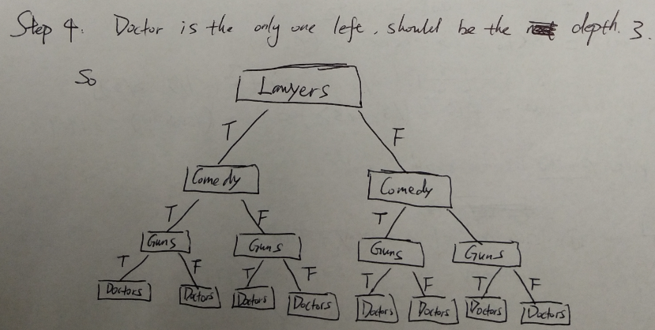

So, this is the final optimized tree

1. [10] For the given test data below, what is the test set error rate using 0/1 loss?

|  |  |  |  |  |  |
| --- | --- | --- | --- | --- | --- |
| Example # | Comedy | Doctors | Lawyers | Guns | *Likes* |
| e13  e14  e15  e16 | true  true  false  true | true  false  true  true | true  true  false  false | true  true  true  false | *false*  *false*  *false*  *true* |

For a logistic regression, you can compute the likelihood function. I would use a McFadden pseudo-R2 , which is defined as:

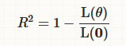

1. [10] Is the data in (3) linearly separable? Explain why or why not..



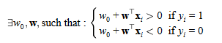

**Q2.** **[50 + 50(program)] *k*-Means Clustering**

Implement the *k*-means algorithm in the slide with the 4-dimensional data at ‘*data1.xls*’. The initial starting points for *k* cluster means can be chosen randomly, where *k*=3. Run the algorithm 10 times with the different initial points, and compute the total sum of squared error after each run. Select the solution that gives the lowest sum of squared error over 10 runs. For the convergence, check if any of the data points change its cluster assignments relative to its previous assignment; i.e. if 1 or more points change cluster assignment, continue to optimize it.

$$L_{2}\left(x_{i}, m_{C_{i}}\right)=\sum_{d=1}^{4}{{(x_{id}-m_{C_{i}})}^{2}}$$

$$Total Sum of Squared Error=\sum_{i=1}^{N}{L_{2}\left(x_{i}, m_{C_{i}}\right)}$$

For each cluster *Ci*, give

(A) [10] its mean (*mi* ),

(B) [10] the size of cluster (i.e. the number of data assigned to *Ci*), and

(C) [30] the list of data which are assigned to each cluster *Ci*.

Do not use the existing or online program of *k*-means algorithm, but do program for yourself, in your favorite language.

1. **Use srand() to generate a random centroids/mean (mi)**

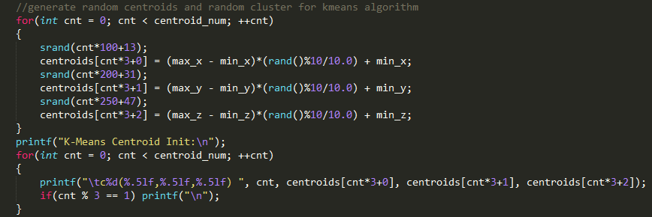

1. **Use dist_2() function to calculate the size of the cluster**

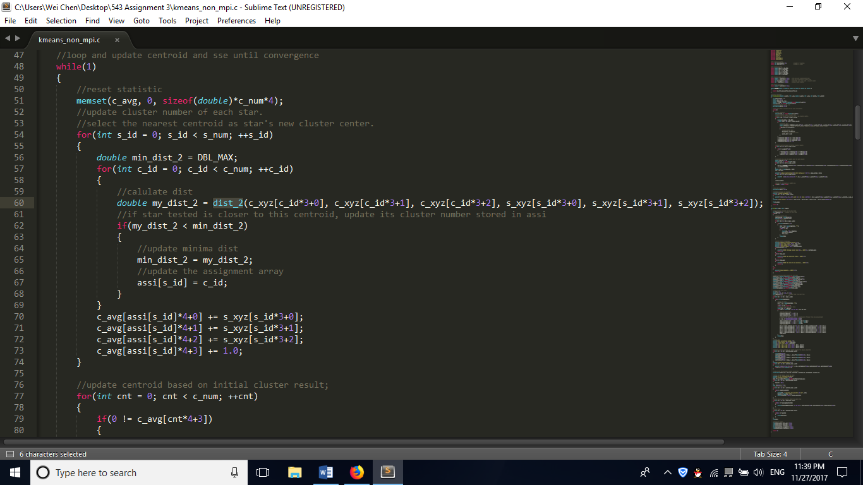

1. **List of data assigned (start 3 processes and run three data files)**

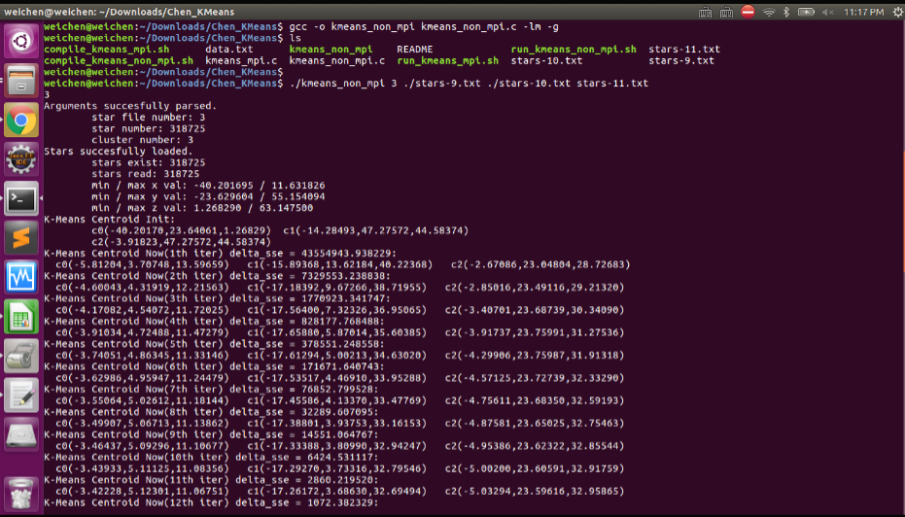

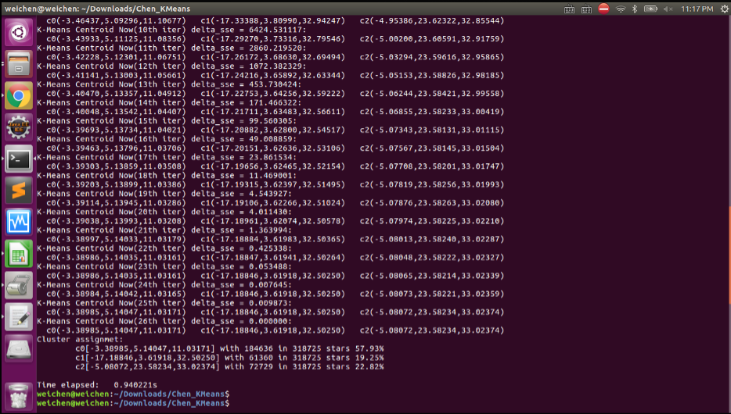

**Q3. [60 + 50(program)] Gaussian Mixture Clustering**

Similarly, implement Gaussian mixture clustering using EM algorithm for the data at *data1.xls*. Assume a Gaussian mixture model of *k* components for the data where *k*=3 and we find the parameters of the model using EM algorithm.

Initialize the parameter values using the result of Q4: i.e. *Ci* from Q4, thus, P(*Ci*) = # of data in *Ci* / *N,* and compute the covariance of each initial group using the data assigned to each cluster in Q2.

For the convergence, compute the value of the log-likelihood after each iteration and stop when there is no significant change within the ε = 0.0001. The log-likelihood under i.i.d assumption is defined as:

$$L\left( | X\right)=\log{\prod_{t=1}^{N}{p(x^{t}|}})=\sum_{t=1}^{N}{\log{\sum_{i=1}^{k}{p\left(x^{t} | C_{i}\right)p(C_{i})}}}$$

where $={\{p\left(C_{i}\right), p\left(x^{t} | C_{i}\right)\}}_{i=1}^{k}$ is the weight for the *kth* component and the Gaussian density for the *kth* mixture component, respectively.

For each component (i.e. cluster) *Ci*, give

1. [5] its weight $w_{i}=p\left(C_{i}\right)$
2. [5] its mean (*mi* ),
3. [5] its covariance (*Si*)
4. [10] $p(C_{i}|x)$ for each data
5. [5] the size of component, and
6. [30] the list of data which are assigned to each component *Ci*.

Do not use the existing or online program, but do program it for yourself, in your favorite language.

**Answer:**

(A) its weight $w_{i}=p\left(C_{i}\right)$

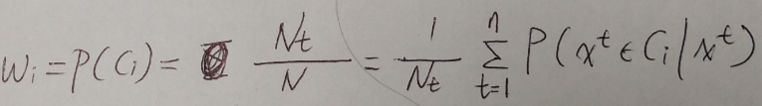

(B) its mean (*mi* )

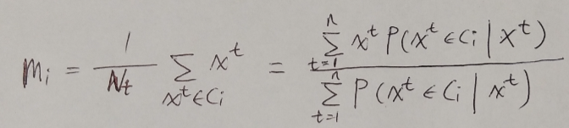

(C) its covariance (*Si*)

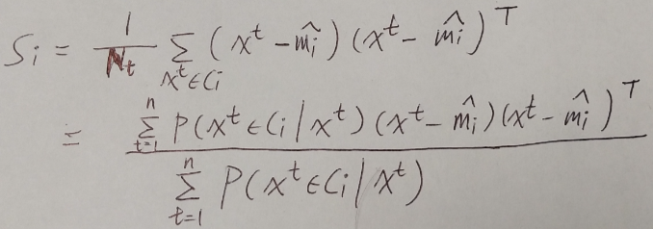

Each component has a covariance matrix. Geometrically, the covariance structure determines the shape of a confidence ellipsoid drawn over a subpopulation or cluster.

Diagonal covariance matrices indicate that the predictors are uncorrelated. The major and minor axes of the ellipses are parallel or perpendicular to the x and y axes. This specification increases the total number of parameters by p, the number of predictors, for each component, but is more parsimonious than the full covariance specification.

Full covariance matrices allow for correlated predictors. There is no restriction to the orientation of the ellipses relative to the x and y axes. Each component increases the total number of parameters by , but captures correlation structure among the predictors. This specification can cause overfitting.

Shared covariance matrices indicate that all components have the same covariance matrix. All ellipses are the same size and have the same orientation. This specification is more parsimonious than the unshared specification because the total number of parameters only increases by the number of covariance parameters for one component.

Unshared covariance matrices indicate that all components have their own covariance matrix. The size and orientation of all ellipses might differ. This specification increases the number of parameters by k times the number of covariance parameters for a component, but can capture covariance differences among components.

**(D) $p(C_{i}|x)$ for each data**

from the likelihood we can get the parameters of each Gaussian

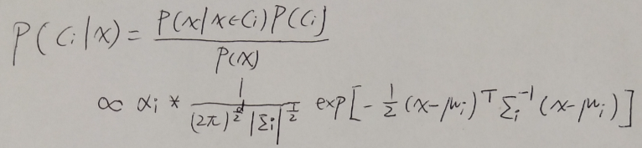

(E) **the size of component**

The EM algorithm comprises the following two steps:

Expectation-step: Given the current parameters, for each class k , compute the component posteriori probability for each data point x I within class k

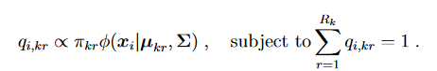

Maximization-step : Update π kr , μ kr , and Σ , which maximize the following objective function

(the I subscript indicates x I with y I = k ):

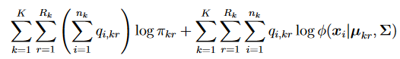

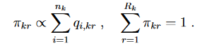

So, the size should be



**(F) the list of data which are assigned to each component *Ci***

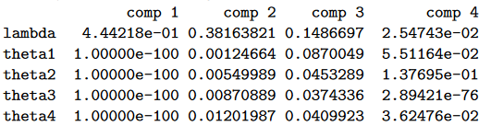

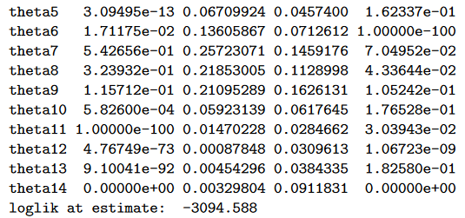

**Q4. [50 + 40(program)] *k*NN: Nonparametric Classification**

The *k*-nearest neighbor class of estimators adapts the degree of smoothing to the local density of data, which is controlled by the number of neighbors, *k* << N where N is the size of data.

Using the same data at *data1.xls* and the clustering result from Q3,

1. **[10] Compute the smooth class-conditional density estimation of each class *Ci*, using kNN where *k*=30 .**

**A distance *dk*(x) is computed by Euclidean distance for a window size *h*.**

**Use a Spheric Gaussian Kernel function with Euclidean norm:**

$$K\left(u\right)={(\frac{1}{\sqrt{2π}})}^{d}exp⁡(-\frac{{\left\|u\right\|}^{2}}{2})$$

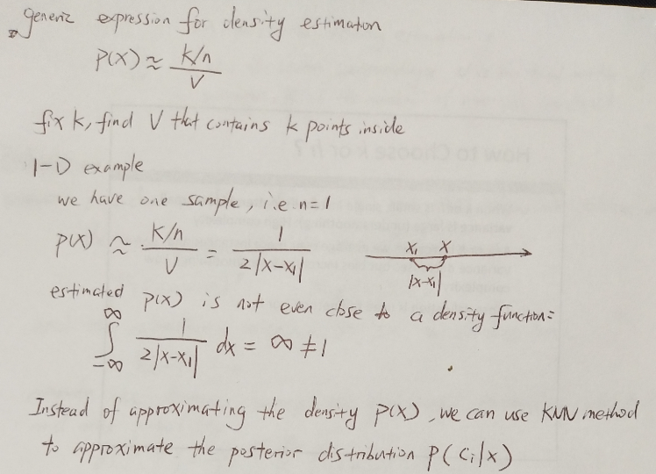

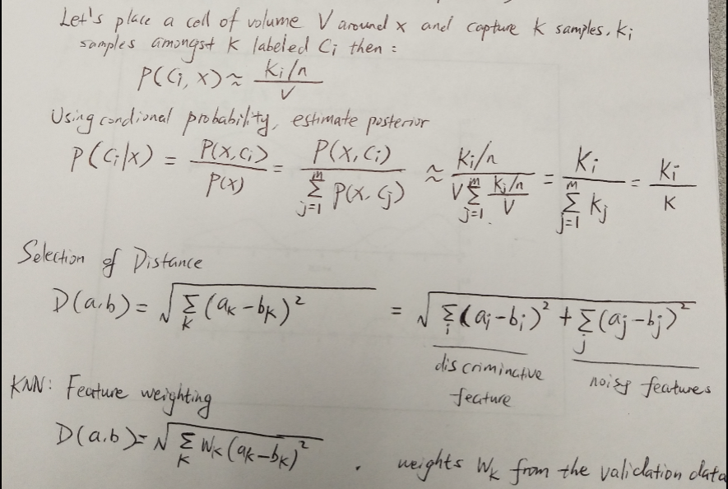

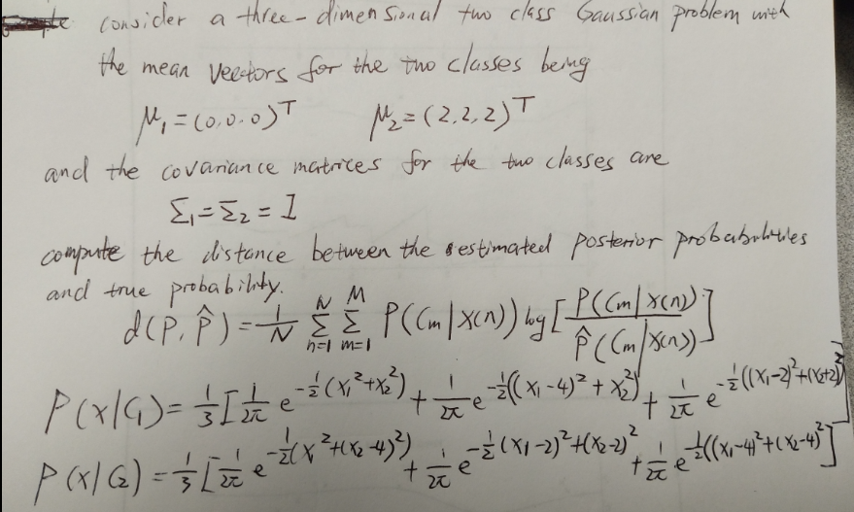

1. **[10] For each data x, compute the discriminant function *gi*(x) for each class *Ci*.**

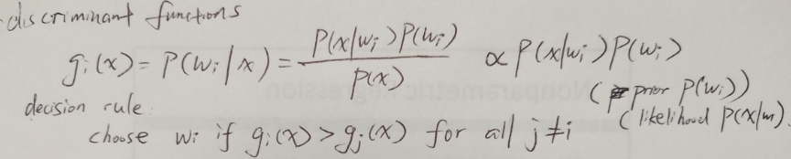

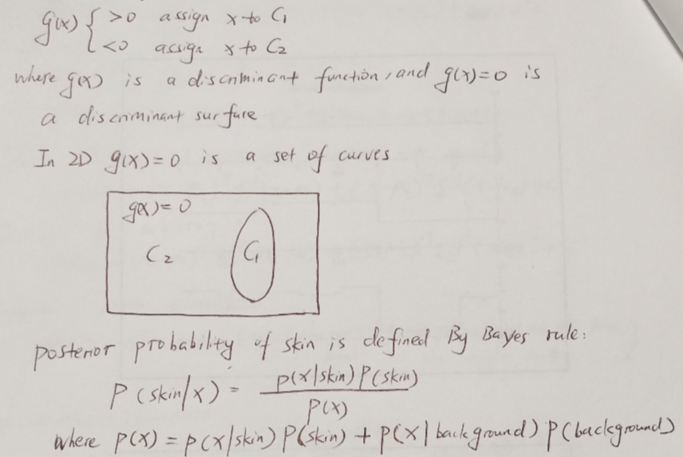

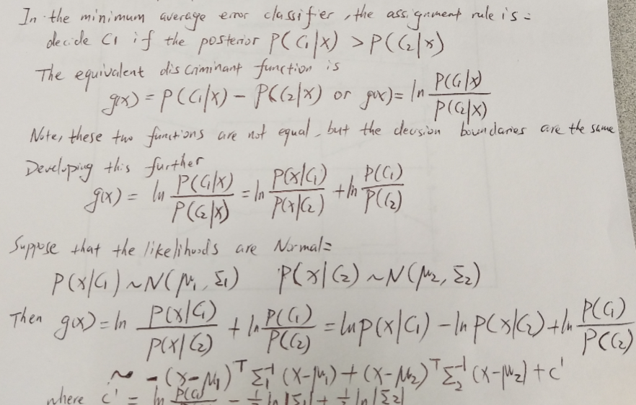

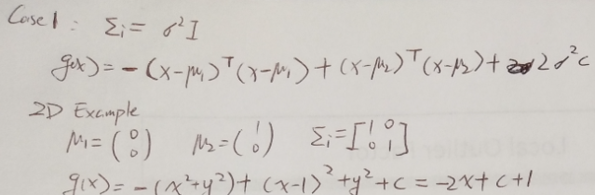

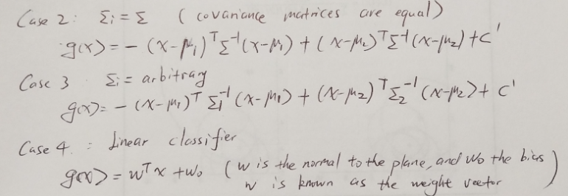

**(C) [30] Based on the result of (B), decide to which class *Ci* each data x is assigned and give the list of data assigned to each *Ci* .**

